# MUHIMBILI UNIVERISITY OF HEALTH AND ALLIED SCIENCE TANZANIA BIOMEDICAL ENGINEERING STUDENT ASSOCIATION

|  |  |
| --- | --- |
| Tel: +255 758 758 153  +255 682 867 205  E-mail: [tabesamuhas@gmail.com](mailto:tabesamuhas@gmail.com) | MUHAS, P.O.BOX 65001, DAR ES SALAAM.  8th AUGUST 2025 |

**TABESA OVERVIEW**

**INTRODUCTION**

The **Tanzania Biomedical Engineering Students Association (TABESA MUHAS)** is a vibrant student-led body that brings together Biomedical Engineering (BME) students under the umbrella of the **Muhimbili University of Health and Allied Sciences (MUHAS)**. The Association was officially formed on **7th November 2023** by **Daudi Elia Daudi**, the founding Chairperson, inspired by the dream of uniting all BME students in Tanzania into one strong, collaborative community. TABESA MUHAS was established to serve as a platform where students can connect, learn, innovate, and contribute to the growth of Biomedical Engineering in the country.

It stands as a bridge between academic learning and practical application, fostering both professional and personal development for its members. As a young but ambitious association, TABESA MUHAS continues to position itself as a center of excellence and collaboration for Biomedical Engineering students, empowering them to be problem-solvers, innovators, and leaders in advancing healthcare technologies in Tanzania and beyond.

**VISION OF ASSOCIATION:**

Our vision is **“ To expose Biomedical Engineers across the horizons of the country so as to create a good pathway for upcoming engineers.”**

**MISSION OF THE ASSOCIATION:**

Our mission is **“To promote and encourage advanced health facilities for all people all over the country through various innovations , projects and knowledge and skills acquired from our Universities”**

**TABESA ACTIVITIES**

The Association emphasizes five key pillars that guide all its activities:

* Innovations
* Trainings
* Research
* Outreaches and
* Scientific Conferences

**AIMS OF TABESA MUHAS**

1. Helping Biomedical Students at MUHAS to acquire equal and good knowledge pertaining to the field profession and use this knowledge to promote advanced health facilities as far as biomedical principles are concerned.
2. Facilitating means of communication among Biomedical students regionally and internationally through the Biomedical Hub.
3. Motivating students to participate innovations, projects and researches based on knowledge and skills got from our university.
4. Building a very strong academic performance to all Biomedical Students by eradicating supplementary and discounts.
5. Promoting gender equality and empower all female Biomedical students.
6. Bridging the gap between Biomedical students with various hospitals and companies dealing with health facilities.
7. Promoting unity, cooperation, discipline and patriotism among students of Biomedical Engineering.

**ASSOCIATION LOGO**

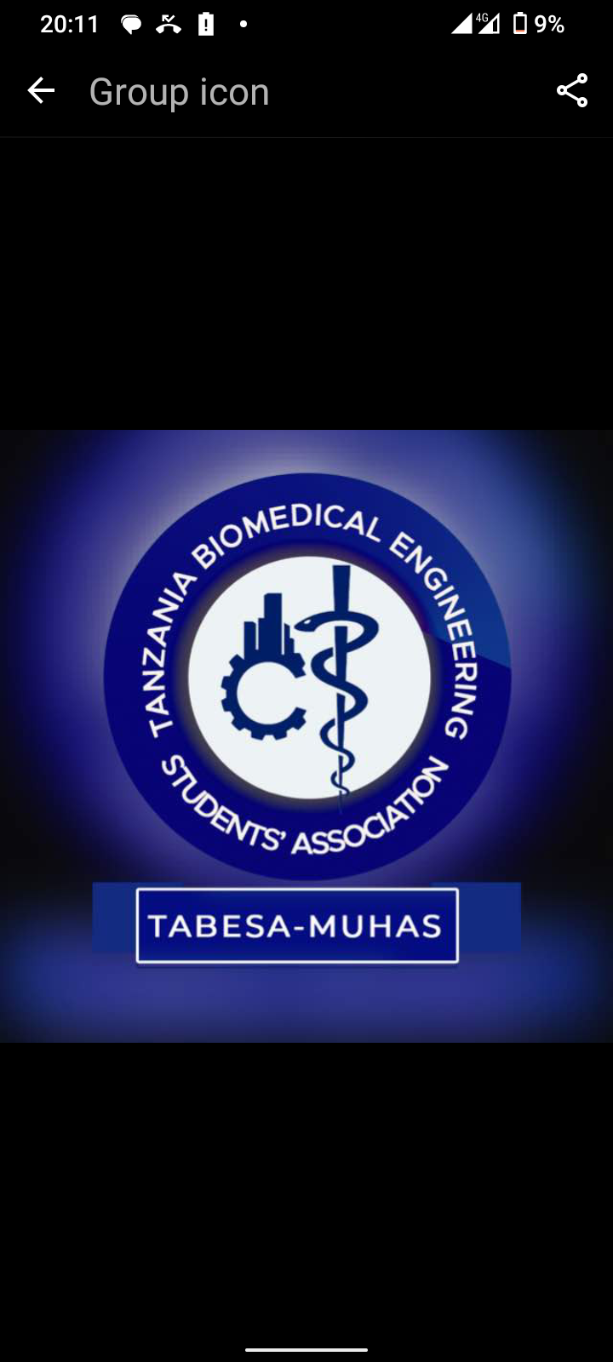

**LEADERSHIP STRUCTURE**

|  |  |
| --- | --- |
| **LEADERSHIP POSITION** | **NAME(S)** |
| **CHAIRPERSON** | **ALLY ABASI RIDHIWANI** |
| **VICE CHAIRPERSON** | **JOCELYNE JOSHUA MWAKILASA** |
| **GENERAL SECRETARY** | **LAWI KIBOGA AKIDA** |
| **ASSISTANT SECRETARY** | **DAVINA KANAN** |
| **TREASURER** | **HENRY LEONARD** |
| **ASSIATANT TREASURER** | **LYDIA JOHN KAGERE** |
| **PROJECT MANAGERS** | **SABRI SALUM, LUIS PAUL, JUNIOUR MARANDU,** |
| **MENTORSHIP OFFICERS** | **PIO RWEHUMBIZA, RADHIA OMARY SABUNI** |
| **IT & PUBLICITY OFFICERS** | **CLAUD PAUL, ASTERIA MALIVA, EMMANUEL DEUS** |
| **ADVISORS** | **BENEDICTUS GWASA, ISACK CHEGELE** |